Create a React Application “eventexamplesapp” to handle various events of the form elements in HTML.

1. Create “Increment” button to increase the value of the counter and “Decrement” button to decrease the value of the counter. The “Increase” button should invoke multiple methods.
   1. To increment the value
   2. Say Hello followed by a static message.

// src/EventExamples.js

import React, { useState } from 'react';

function EventExamples() {

  const [count, setCount] = useState(0);

  const increment = () => {

    setCount(prev => prev + 1);

    sayHello();

    staticMessage();

  };

  const decrement = () => {

    setCount(prev => prev - 1);

  };

  const sayHello = () => {

    console.log("Hello");

  };

  const staticMessage = () => {

    console.log("This is a static message!");

  };

  const sayWelcome = (msg) => {

    alert(msg);

  };

  const handleClick = () => {

    alert("I was clicked");

  };

  return (

    <div style={{ padding: '20px' }}>

      <h2>🎯 Event Handling in React</h2>

      <p>Counter: {count}</p>

      <button onClick={increment}>Increment</button>{' '}

      <button onClick={decrement}>Decrement</button>

      <br /><br />

      <button onClick={() => sayWelcome("Welcome!")}>Say Welcome</button>

      <br /><br />

      <button onClick={handleClick}>Synthetic OnPress</button>

    </div>

  );

}

export default EventExamples;

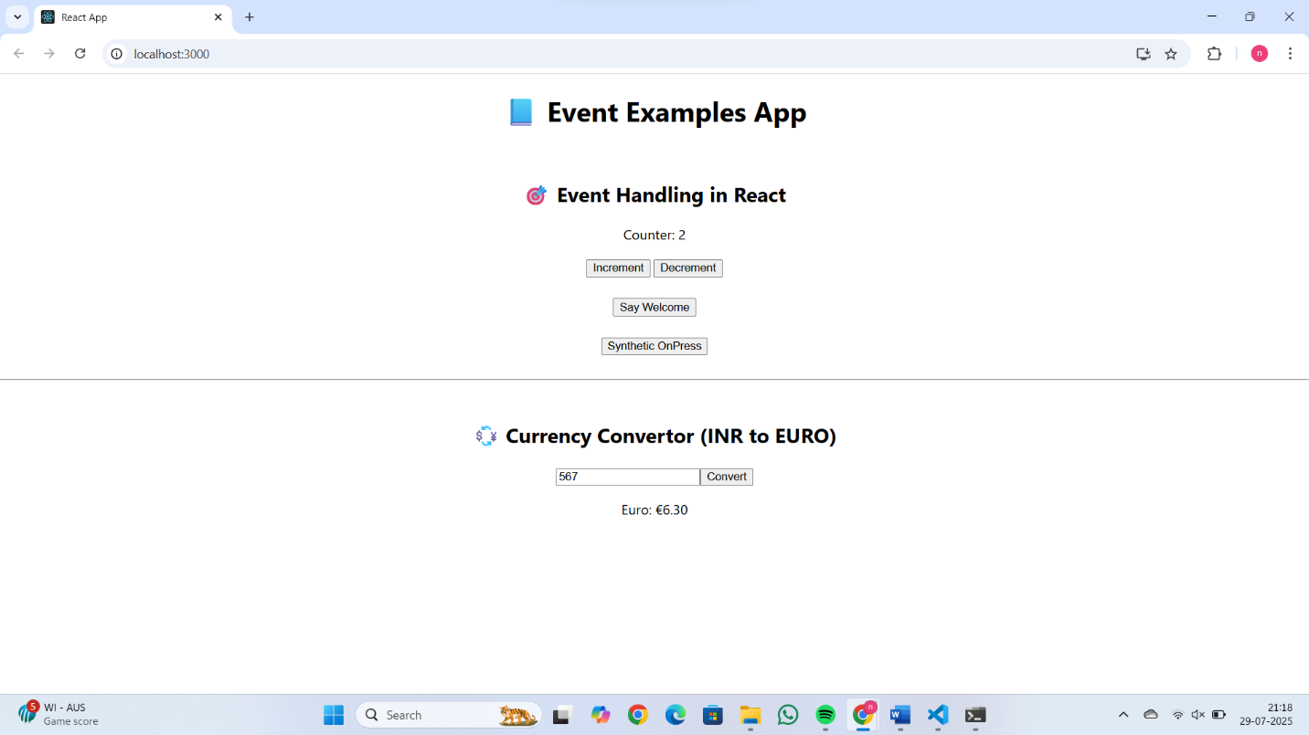

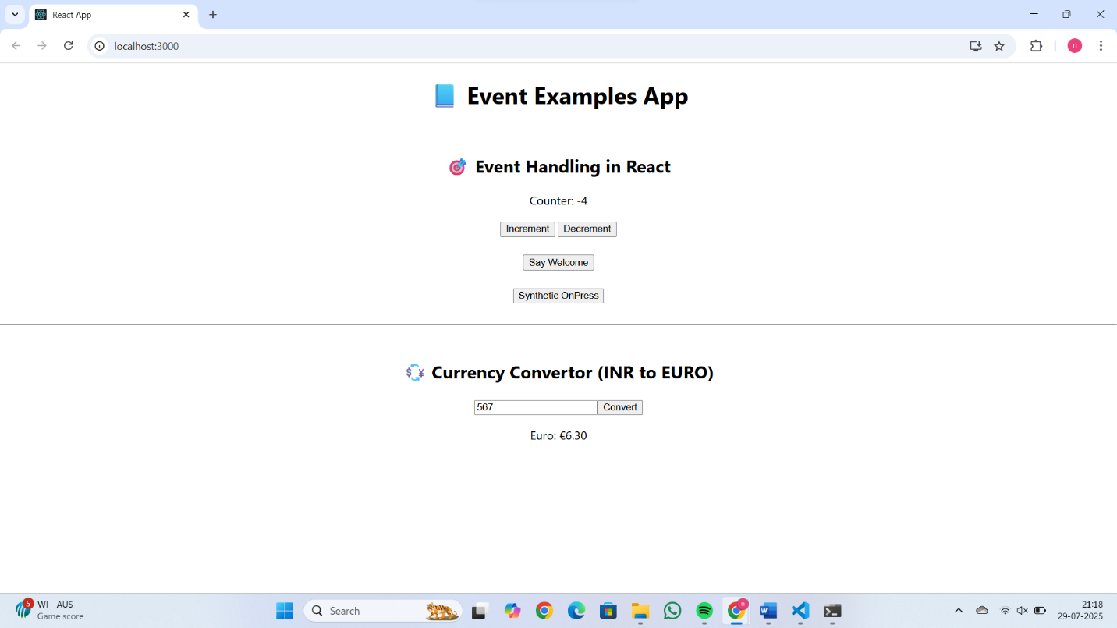

1. Create a button “Say Welcome” which invokes the function which takes “welcome” as an argument.

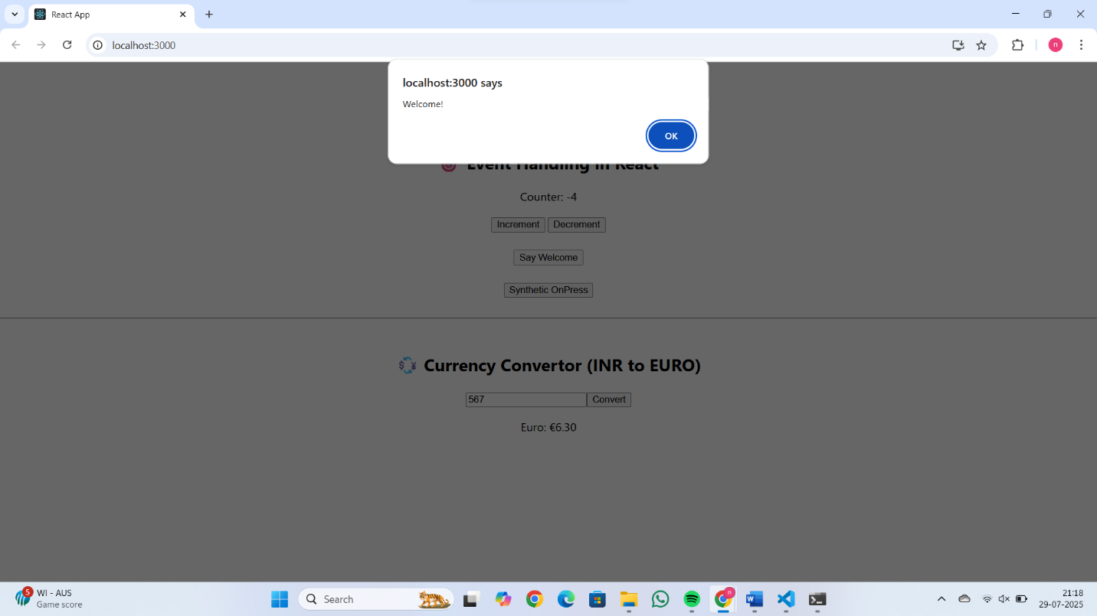

1. Create a button which invokes synthetic event “OnPress” which display “I was clicked”

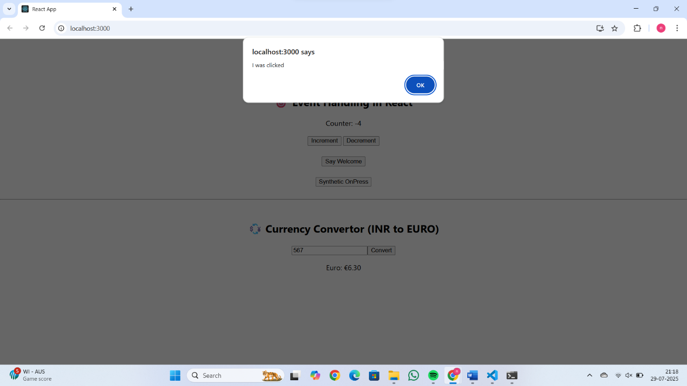

Create a “CurrencyConvertor” component which will convert the Indian Rupees to Euro when the Convert button is clicked.

// src/CurrencyConvertor.js

import React, { useState } from 'react';

function CurrencyConvertor() {

  const [rupees, setRupees] = useState('');

  const [euro, setEuro] = useState('');

  const handleSubmit = () => {

    const euroValue = parseFloat(rupees) / 90; // example conversion rate

    setEuro(euroValue.toFixed(2));

  };

  return (

    <div style={{ padding: '20px' }}>

      <h2>💱 Currency Convertor (INR to EURO)</h2>

      <input

        type="number"

        value={rupees}

        onChange={(e) => setRupees(e.target.value)}

        placeholder="Enter amount in ₹"

      />

      <button onClick={handleSubmit}>Convert</button>

      {euro && (

        <p>Euro: €{euro}</p>

      )}

    </div>

  );

}

export default CurrencyConvertor;

Handle the Click event of the button to invoke the handleSubmit event and handle the conversion of the euro to rupees.

